1. 
2. **Process**:
   1. Instance of Application/Program.
   2. When you load an application such as code editor or music player, your OS loads the app inside a process. So process contains an **image** of application code. It has memory and other resources.
   3. OS can execute many processes at the same time such as you’re editing some image along with downloading something. That is the concurrency at the process level.
   4. We have concurrency within the process (within the app) using threads.

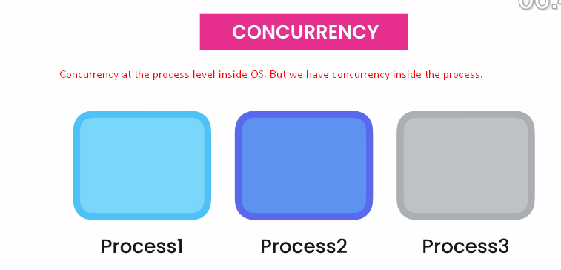

1. **Thread**: Technically speaking, thread is a sequence of instructions. It is a thread of instructions. That’s why it’s called thread.  
   Practically speaking, thread is that thing that executes your code.   
   Followings are the example for threads within a process:  
     
   **Multi-Threaded Application**: The application using multiple threads is called **Multi-Threaded App**.
2. **Processors & Cores**: Most Processors have multiple cores. These cores can be used to run multiple processes/threads. If your application is not using threads, it is that your app is using one core. So your app is not utilizing the full power of CPU**.**
3. 